These instructions describe how to set up Web Files access using Pages on an iPad. The process is the same for Pages, Keynote, and Numbers on any iPad running the most current version of the apps.

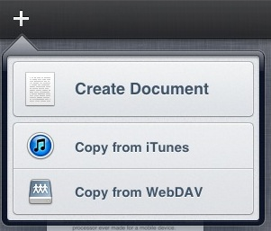
- Open Pages and tap the + symbol in the upper left hand corner. Select Copy from WebDAV.
- In the Server Address field type in https://webfiles.oaisd.org/htcomnet/hcwebdav. The User Name and Password fields will be filled in with your Computer Login credentials. 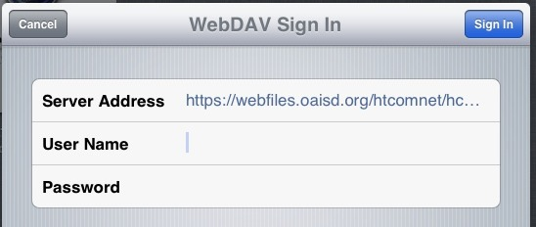
- Choose Home for your personal network drive and choose Share for the staff share drive. 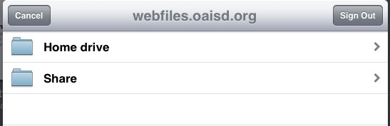
- Choose the document type you would like to load (Pages, Word, PDF).
- Open the document and make any changes you would like. Pages automatically saves changes as they are made to the iPad.

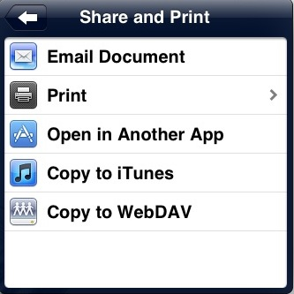
- Once you are done working with the file you need to upload it in order for it to be available on other devices. To do this touch the Wrench icon in the upper right to open the Tools window. Once the Tools window is open touch Share and Print.
- Choose Copy to WebDAV and the type of document you would like to save (Pages, PDF, Word). We recommend using Word as the format.
- Choose the location to save the file by touching Home or Share and any subfolders. Then touch Copy in the upper right corner.
- The file will be copied to the specified location and will be available to access on other devices now.

